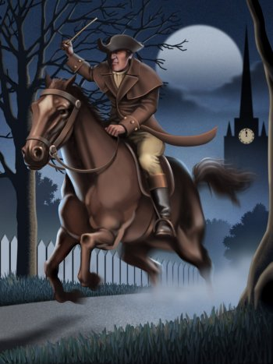
Collections Grade 6 Guiding Questions
Collection 5

“Paul Revere’s Ride” by Henry Wadsworth Longfellow

Read the poem “Paul Revere’s Ride” by Henry Wadsworth Longfellow. Then, reread the lines indicated with each question below. Answer each question, citing text evidence.

- Lines 1–14: How is the beginning of this poem similar to the beginning of a story? Support your ideas with evidence from the poem.
- Lines 15–41: Where are Paul Revere and his friend? How do you know?
- Lines 20–23: What mood does Longfellow create in these lines? What words and phrases create this effect?
- Lines 24–30: What words create mood in these lines? What is the mood?
- Lines 42–56: What effect do these lines have on the reader? How do they fit into the overall structure of the poem?
- Lines 64–72: What is Revere watching? What does he eventually see? Describe the key event that happens at the end of this stanza. How do you know this?
- Illustrations: How do these illustrations convey the idea that the “fate of a nation was riding that night”?
- Illustrations: How do these illustrations and the poem they portray compare to stories you have read in general or, more specifically, to historical stories and narratives you know? Compare and contrast how those stories do and do not seem similar to this narrative poem. How do the illustrations contribute to your ideas?
- Lines 78–86: Explain the effect of the rhyming words in these lines.
- Lines 78–110: How does Longfellow structure the climax of the poem? What specific stanzas support your ideas?
- Lines 97–100: How do these lines fit into the structure of the poem?
- Lines 111–118: What does Longfellow describe in these lines? Why does he begin line 111 with “You know the rest”?
- Lines 119–130: Why does Longfellow include these lines?

