Franklin Academy Boynton Beach
Grade 7 Project – Greek Roots
Unit 2: “Living in the Dark”

Assignment: Greek Roots Display

Mode: In-class project (25 project marks)

Task:

The informational article “Living in the Dark” (p. 201-208) refers to many terms that include Greek roots, since modern civilization owes a great deal to the Ancient Greeks for discoveries in earth and life science. In the Vocabulary Strategy section following the article (p. 211 in your textbook), several Greek roots and terms with those roots are introduced. Choose any Greek root and find three (3) words containing each root.

Directions:

- Sketch out your project on loose leaf paper first before beginning the final draft.
- Use 9 x 12” construction paper (which I will provide) for your final draft.
- Write your chosen root in large print in the center of the paper with the definition of the root clearly written below it
- Around the root, write each word in a separate space including its part of speech (noun, verb, etc.) and dictionary definition.
- For each word, add a picture (drawn or cut/pasted) related to the word and a brief caption describing it.
- Your text may be typed onto paper and pasted onto the construction paper or handwritten in colored marker directly onto the construction paper.

Sample Project Poster

HYDROPONICS (noun) HYDROPLANE (noun)
a method of growing plants in water a boat that is designed to
rather than in soil move over water at very
high speeds

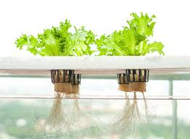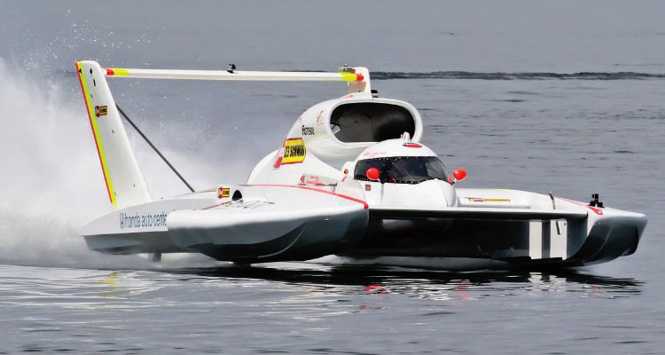
HYDROPONIC PLANTS HYDROPLANE RACES
HYDRO-
(“water”)

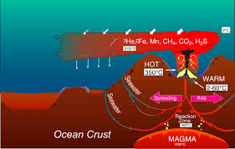

HYDROTHERMAL (adj.) of or relating to hot water —used especially of the formation of minerals by hot solutions rising from a cooling magma

HYDROTHERMAL VENTS EMITTING CARBON DIOXIDE IN THE MARIANAS TRENCH

