Calligram Project
A calligram is a text visually arranged in a way that it forms an image associated with the text's contents. It can be a poem, a phrase, or a single word. The image created by the words illustrates the text by expressing visually what it says, or something closely associated. Below are examples.
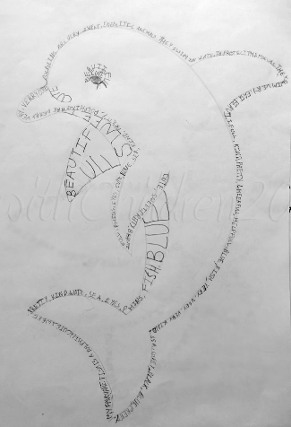
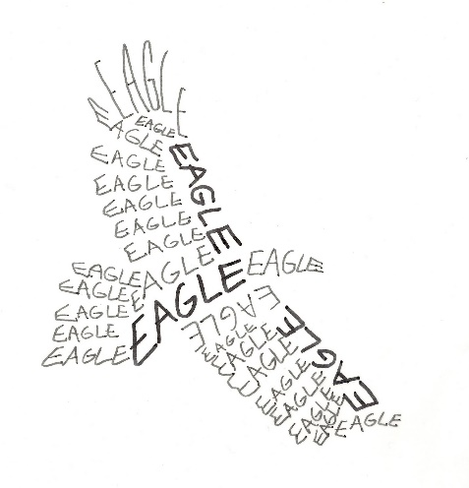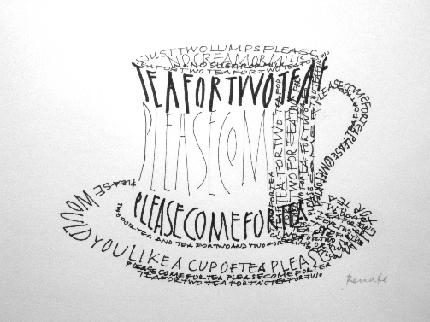

PROJECT OBJECTIVE: To take the research you have done for your “Pioneer” essay and create a calligram image representative of that person. For example, if you wrote your “Pioneer” essay about Michael Jordan, then you may want to create an image of a basketball or a sneaker. Or if you chose Amelia Earhart, then you may want to create a calligram image of an airplane. The words you use to create your image will be directly tied to the information used in the research paper about a person of minority that has broken boundaries. Let’s see how you can turn all of those facts and figures into a work of art!
STANDARDS:
GRADE: Project grade – 50 points
DIRECTIONS: Create a calligram in the shape of an image of your choosing by using words, dates, and phrases related to the person written about in your “Pioneer” essay.
- You must use a minimum of at least 15 different words, dates, or phrases related to the person you wrote your essay about to create the image.
- Must be done on a white sheet of 8 1/2 x 11 paper.
- You must use only colored pencils (NO markers, crayons, or pens). You should use from 3-12 different colors. Use colors that have been either inspired by the person you are writing about or the image itself. For example, if you wrote about Michael Jordan you may want to use the color red because it is one of the Chicago Bulls team colors. Or if you wrote about Harriet Quimby you may want to use the color green because she had green eyes.
- On a separate sheet of paper (hand-written or typed), submit a 3-5 paragraph paper that:
  - Explains how the image you chose represents the person you wrote your essay about.
  - Explains the importance of the dates, words and phrases used to create the image.
  - Explains the significance of the colors you used to create the image.

