4 Reasons Why Scientists Should Explore the Oceans:
https://io9.gizmodo.com/should-we-be-exploring-the-oceans-instead-of-space-1619346783
Climate
“A plethora (lots) of viable solutions to the Earth's most pressing [climate] troubles [may come from exploring the ocean.] For example, scientists have already demonstrated that the oceans serve as a "carbon sink." The oceans have absorbed almost one-third of anthropogenic CO2 emitted since the advent of the industrial revolution and have the potential to continue absorbing a large share of the CO2 released into the atmosphere. Researchers are exploring a variety of chemical, biological, and physical geoengineering projects to increase the ocean's capacity to absorb carbon. Additional federal funds should be allotted to determine the feasibility and safety of these projects and then to develop and implement any that are found acceptable.”
Food
“Ocean exploration, however, has the potential to be of great help to feed people”.
“Aquaculture is rapidly expanding—more than 60% from 2000 to 2008—and represents more than 40% of global fisheries production in 2006. A number of challenges require attention if aquaculture is to significantly improve worldwide supplies of food. First, scientists have yet to understand the impact of climate change on aquaculture and fishing. Ocean acidification is likely to damage entire ecosystems, and rising temperatures cause marine organisms to migrate away from their original territory or die off entirely. So it is important we study the ways that these processes will likely play out and how their effects might be mitigated.”

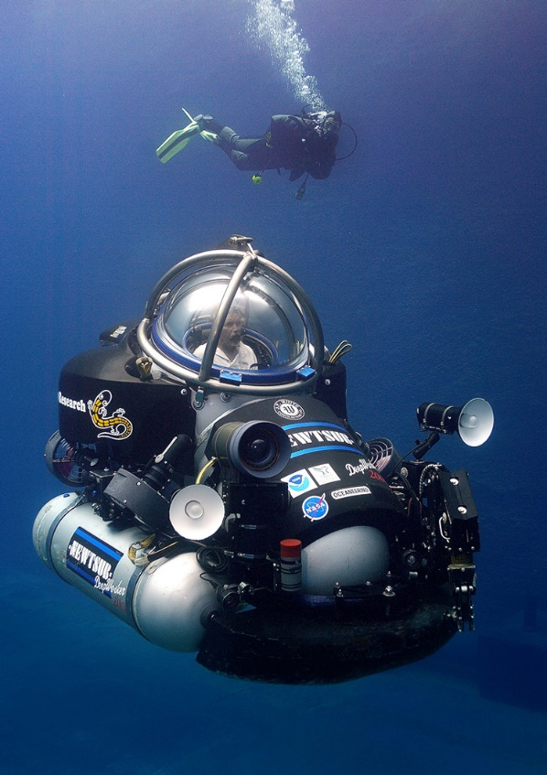
Health
“Ocean research, as modest as it is, has already yielded several medical "spinoffs" or advances in medicine. The discovery of one species of Japanese black sponge, which produces a substance that successfully blocks division of tumorous cells, led researchers to develop a late-stage breast cancer drug. An expedition near the Bahamas led to the discovery of a bacterium that produces substances that are in the process of being synthesized as antibiotics and anticancer compounds. In addition to the aforementioned cancer fighting compounds, chemicals that combat neuropathic pain, treat asthma and inflammation, and reduce skin irritation have been isolated from marine organisms….[Yet] up to two-thirds of all marine life remains unidentified.”

To Learn New Things about The Planet We Live On
“Furthermore, for years scientists have been fascinated by noises originating at the bottom of the ocean, known creatively as "the Bloop" and "Julia," among others. And the world's largest known "waterfall" can be found entirely underwater between Greenland and Iceland, where cold, dense Arctic water from the Greenland Sea drops more than 11,500 feet before reaching the seafloor of the Denmark Strait. Much remains poorly understood about these phenomena, their relevance to the surrounding ecosystem, and the ways in which climate change will affect their continued existence.
“In short, there is much that humans have yet to understand about the depths of the oceans, further research into which could yield important insights about Earth's geological history and the evolution of humans and society. Addressing these questions surpasses the importance of another Mars rover or a space observatory designed to answer highly specific questions of importance mainly to a few dedicated astrophysicists, planetary scientists, and select colleagues.”

