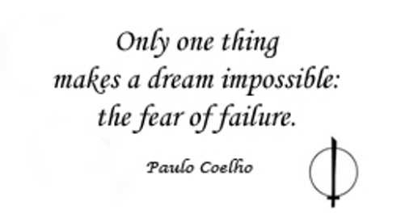
English 1
“Facing Fear” – Writing Assignment (10 test marks)
Essay Topic: To explain how fear plays an important role in our lives, utilizing text evidence from “Fears and Phobias” and “The Ravine”
Plan: You must create a plan that identifies the introduction, main body parts, and conclusion of your essay
Essay Structure
Introduction
- Utilize a hook, anecdote, or example to illustrate how fear can affect people
- Identify the focus topic/central idea of your essay – how fear can be helpful
- Identify the examples you will explore in your main body paragraphs
Main Body Paragraphs
- Cite evidence and elaborate on examples found in “Fears & Phobias” to explain how fear can be helpful to us
- Research and cite evidence to provide further evidence of how fear can be helpful for a specific type of fear. Cite evidence from your research and explain how this fear is helpful to people.
- Cite evidence and elaborate on examples found in “The Ravine” to explain how Vinny’s fear was helpful to him.
Conclusion
- Restate the purpose of your writing task
- Answer the central question
- Summarize how your examples in main bodies prove how fear is helpful
- Provide a concluding statement about how your understanding of fear has changed throughout your reading

